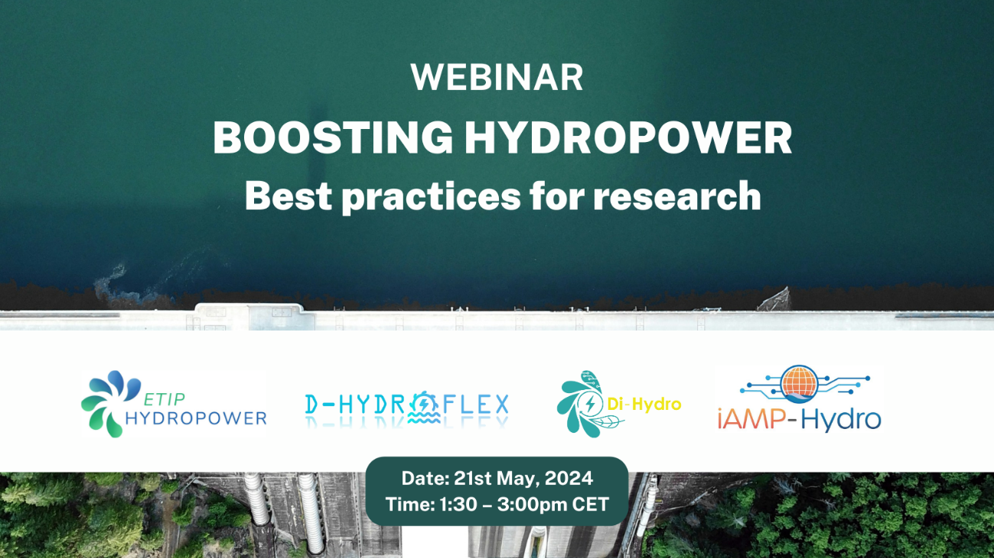

Get ready for the upcoming webinar featuring three newly EU-funded projects along with ETIP Hydropower next 21 May 2024 (13:30 – 15:00 CET)!

Europe has significant hydropower potential due to its diverse altitude landscape and surrounding seas. However, only a small fraction (13.8%) of the EU's net electricity generation comes from hydropower plants. This low utilization is primarily attributed to inadequate digital management, handling, and maintenance of HPPs compared to other energy generation methods.

In the webinar, the following projects will be presented:

**Katerina DRIVAKOU (Technical Coordinator, UBITECH)** will talk on behalf of **D-HYDROFLEX,** a project that aims to develop a toolkit for digitally renovating existing hydroelectric power plants based on sensors, digital twins, AI algorithms, hybridization modelling (power-to-hydrogen), cloud-edge computing, and image processing. Validation will take place in 7 hydro plants across Europe, addressing challenges posed by the European Green Deal and the Digital Decade Policy Programme 2030.

**Alkiviadis TROMARAS (Project Coordinator, CERTH)** will represent **Di-Hydro** an initiative that aims to digitize hydropower plants by developing smart devices and data acquisition techniques. Digital twins will facilitate real-time data exchange, enabling optimal coordination of power generation considering societal, weather, water flow, environmental, and biodiversity data.

**Aonghus MCNABOLA (Project Coordinator, Trinity College Dublin**) will speak for **iAMP-Hydro,** a project that focuses on developing digital solutions to address the evolving needs of the EU hydropower sector. With a significant portion of hydro generation assets slated for potential upgrades by 2030, the project aligns closely with energy sustainability and digital transformation imperatives. By harnessing the collective capabilities of diverse partners, iAMP-Hydro seeks to unlock pathways for optimizing asset performance, minimizing environmental impact, and fostering socio-economic development in communities served by hydropower facilities.

In addition, we will count on the presence of **Emanuele Quaranta** who will provide the audience with an overview **about research for hydropower** on behalf of the European Commission. **Anton Schleiss**, as technical coordinator, will represent **ETIP HYDROPOWER** during the session.

**Register now** to secure your spot at the ETIP Hydropower webinar on 21 May 2024: <https://attendee.gotowebinar.com/register/6616868010758880343>

**More information and agenda:** <https://etip-hydropower.eu/events/etip-hydropower-and-new-hydropower-horizon-projects/>